**DBMS: LAB ASSIGNMENT-2**

**NAME :** Mohammed Abdul Haseeb

**ROLL NO :** 20BCS085

**AIM :** As per the given report we are supposed to create Table for given entities and attributes , Updating the created table according to the problem statement**.**

**Experiments:**

use mysql;

create table category_details

(category_id numeric (2),

category_name varchar (30) );

select * from category_deatails;

create table Sub_category_details

(sub_category_id numeric(2),

category_id numeric(2),

sub_category_name varchar(30));

create table Product_details

(Product_id numeric (6),

category_id numeric(2),

sub_category_id numeric(2),

product_name varchar(30));

**From above code category_details,sub_category_details, product_details, those entities and attributes are created into a table .**

ALTER TABLE Category_details

ADD PRIMARY KEY (category_id);

ALTER TABLE Sub_category_details

ADD CONSTRAINT PK_sub_category_id PRIMARY KEY (sub_category_id);

ALTER TABLE Sub_category_details

ADD CONSTRAINT FK_category_id foreign key (category_id) REFERENCES Category_details(category_id) ;

ALTER TABLE Product_details

ADD CONSTRAINT PriKey_Product_id PRIMARY KEY (Product_id),

ADD CONSTRAINT ForKey_category_id foreign key (category_id) REFERENCES Category_details(category_id),

ADD CONSTRAINT ForKey_sub_category_id foreign key (sub_category_id) REFERENCES Sub_category_details(sub_category_id) ;

**From above code primary keys, foreign key added to the created table.**

ALTER TABLE Product_details ADD price numeric(2);

ALTER TABLE Product_details

modify COLUMN price numeric(6,2);

**In the above code price column was added and it’s data type was changed.**

INSERT INTO Category_details VALUES (1,'aa');

INSERT INTO Category_details VALUES (2,'bb');

INSERT INTO Category_details VALUES (3,'cc');

INSERT INTO Category_details VALUES (4,'dd');

INSERT INTO Sub_category_details VALUES (11,1,'dd');

INSERT INTO Sub_category_details VALUES (12,2,'ee');

INSERT INTO Sub_category_details VALUES (13,3,'ff');

INSERT INTO Sub_category_details VALUES (14,4,'gg’);

INSERT INTO Product_details VALUES (1111,1,11,'hh',50);

INSERT INTO Product_details VALUES (1112,2,12,'ii',60);

INSERT INTO Product_details VALUES (1113,3,13,'jj',70);

INSERT INTO Product_details VALUES (1114,4,14,'kk',80);

**At last sample values were given to the entities.**

ALTER TABLE Product_details Drop price;

**Dropping the price columns from the product details table.**

**ER DIAGRAM :**

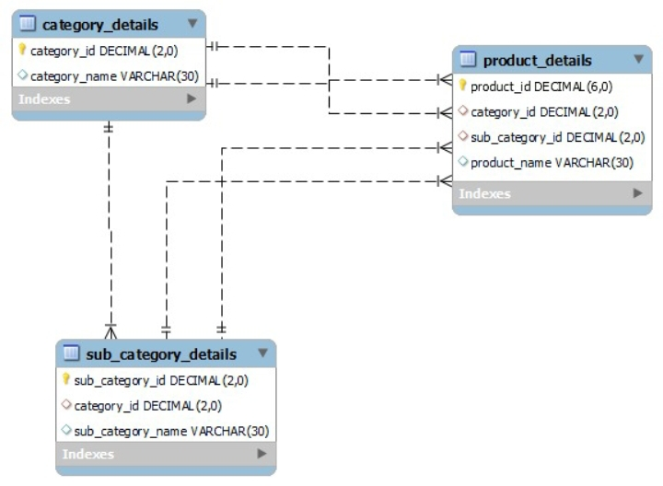

**Result:**

**As mentioned in the experiment part here are the snaps of the created table .**

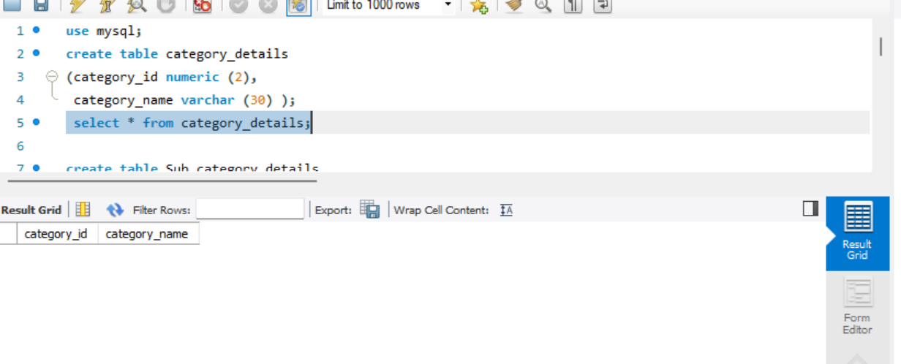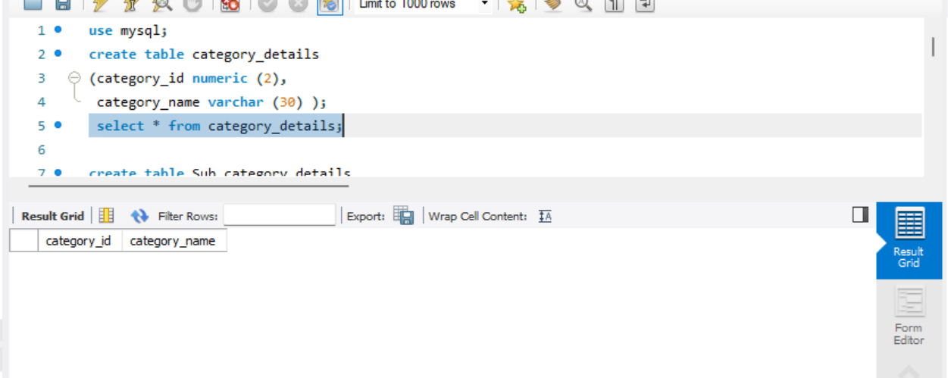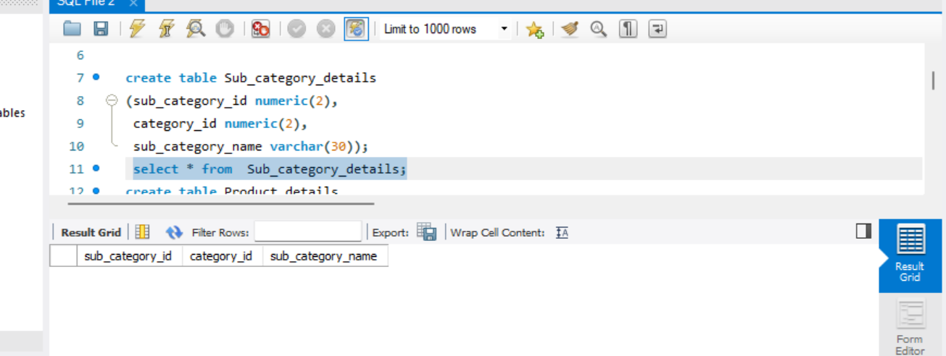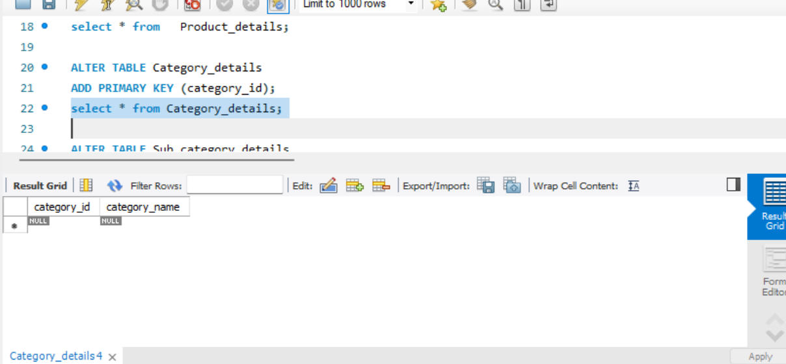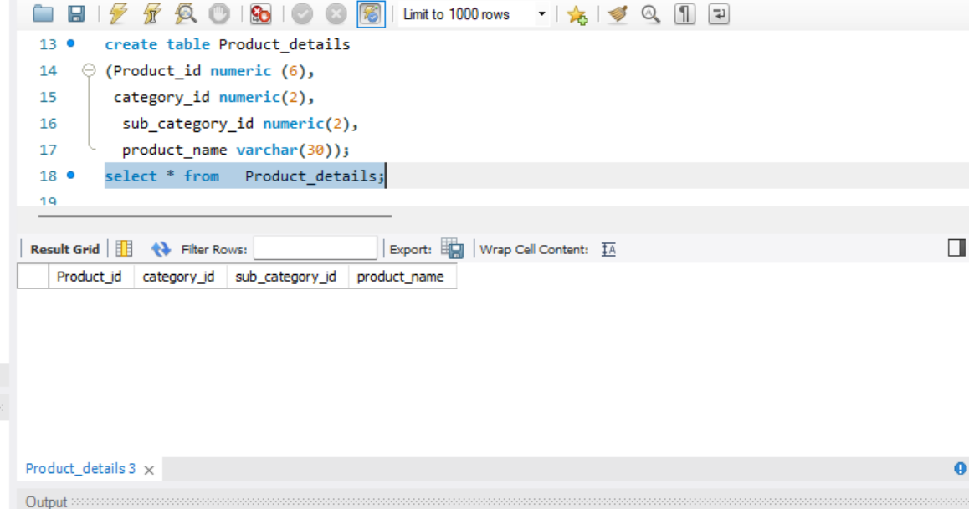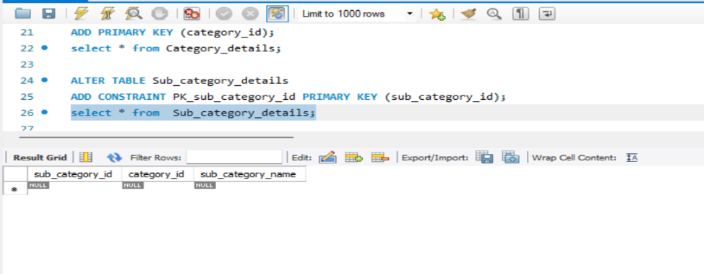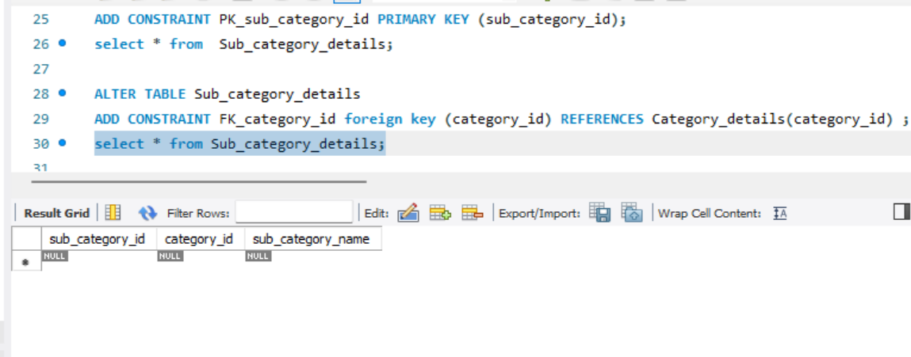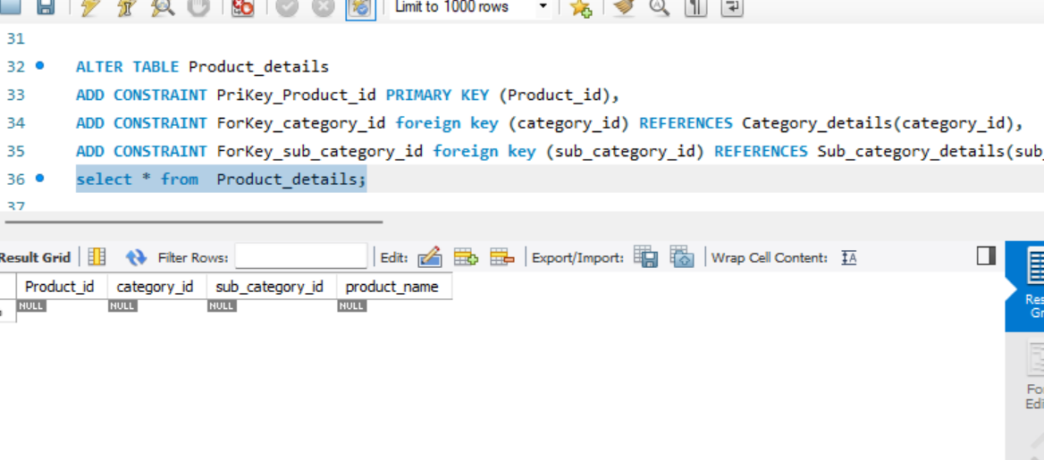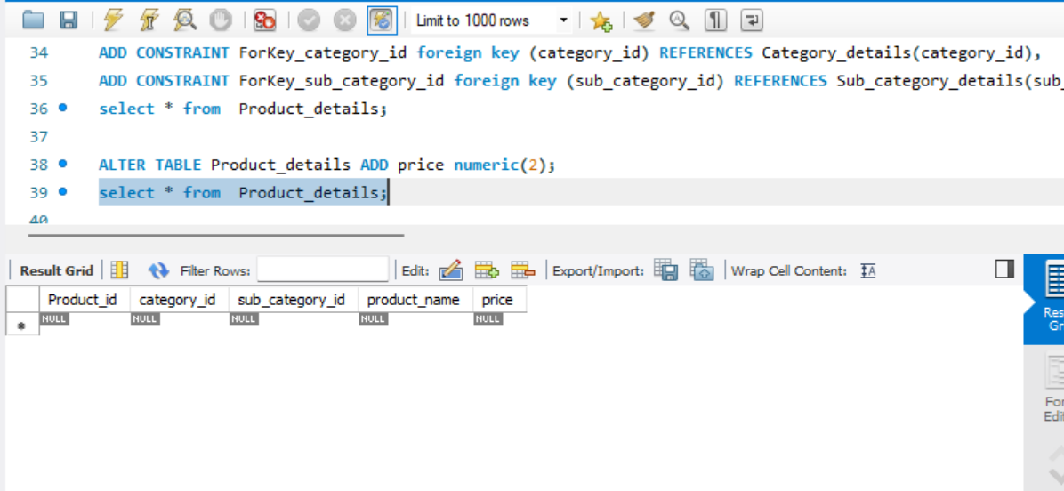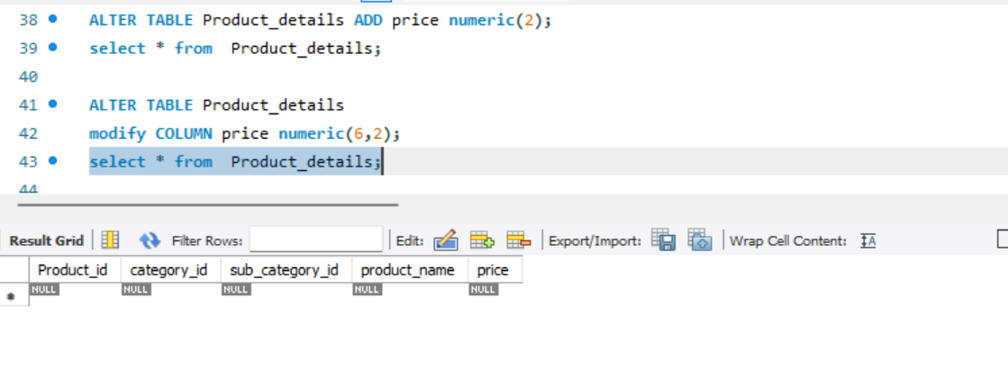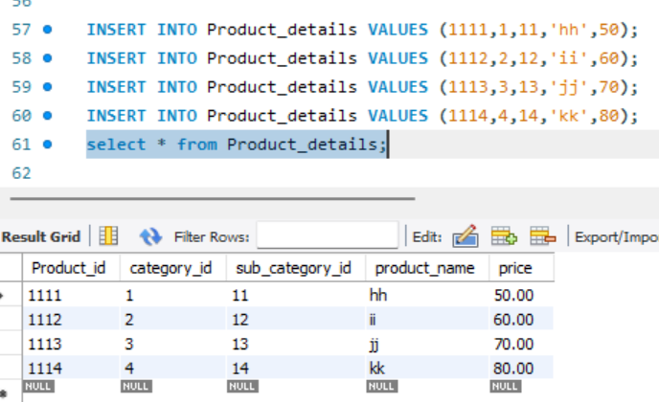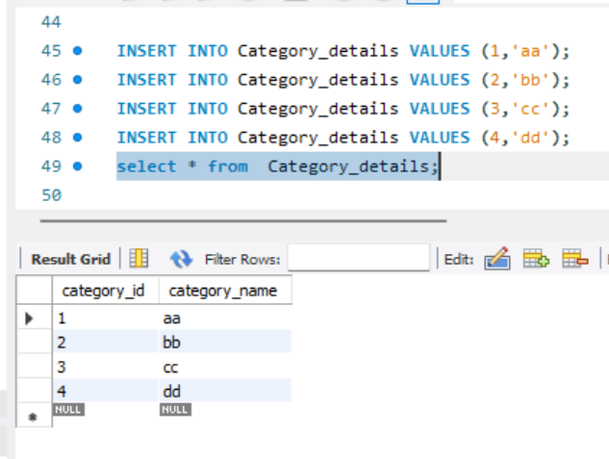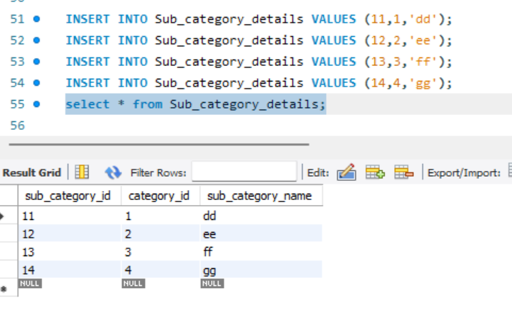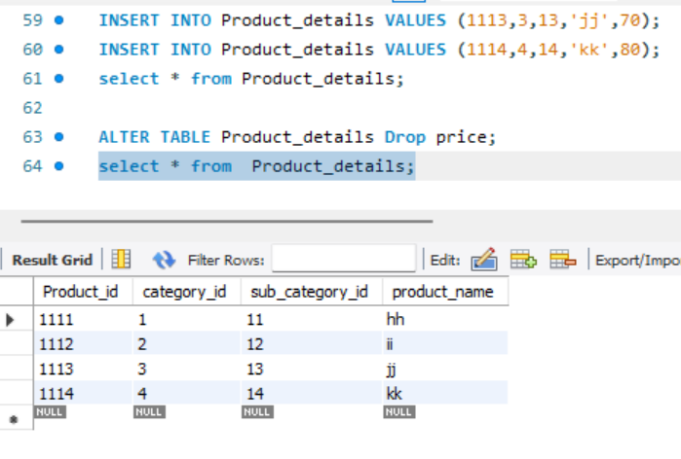

**Conclusion:**

SQL database are the most prominent database, in which data can be inserted in form of tables with the help of some commands. Through these commands, one can create tables, and in each table, one can declare some entities.we can have entities named Primary keys which are used to identify the rows/tuples uniquely and foreign keys which are used to relate two different tables. These 2 keys can have constraints with/without constraint names. The columns/entities can also be added , modified, or dropped even after tables are declared. With the ‘insert’ command we can add the tuples/rows with carefully chosen primary and foreign keys.

**\*------The End ------\***